AI ASSISTED CODING LAB

ASSIGNMENT 1.2

ENROLLMENT NO :2503A51L33 BATCH NO: 20

NAME: Thirumalakonda Shiva

TASK DESCRIPTION 1: Function to check if a string is a valid

palindrome (ignoring spaces and case) and allow Copilot to complete it.

PROMPT 1: generate Function to check if a string is a valid palindrome (ignoring spaces and case).

* Define a function is_palindrome(s) that returns True if the string is a palindrome and False otherwise.
* Ignore spaces and make the check case-insensitive.
* Let GitHub Copilot complete the logic inside the function.

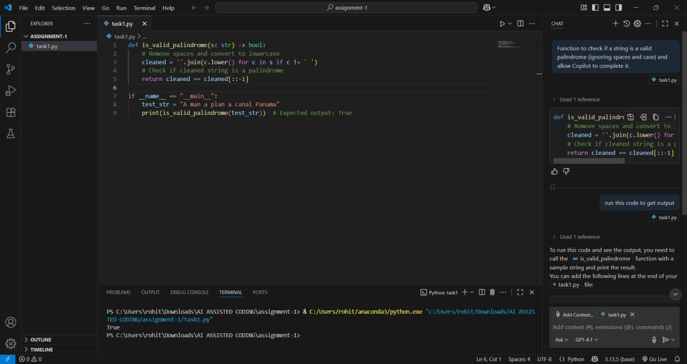

TASK DESCRIPTION 2: Generate a Python function that returns the Fibonacci sequence up to n terms. Prompt with only a function header and docstring

PROMPT 1: Generate a Python function upto 10 sequences that returns the Fibonacci sequence up to n terms. Prompt with only a function header and docstring

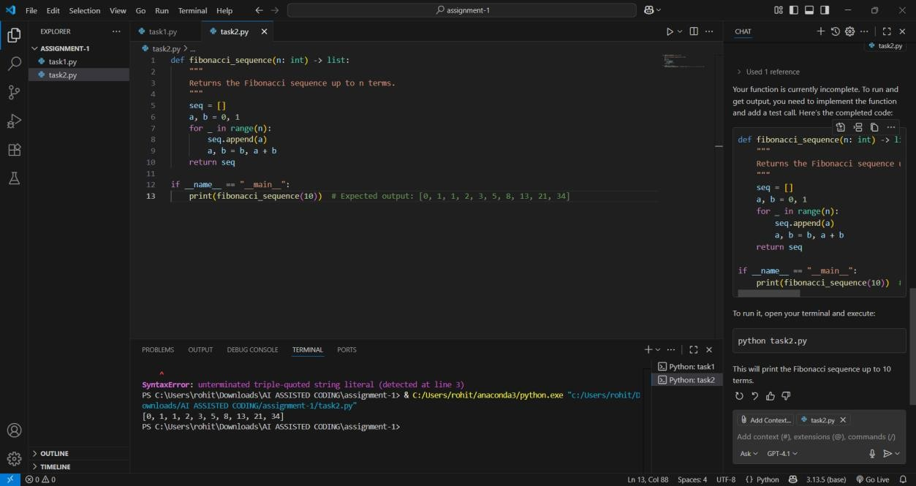

TASK DESPRICTION 3: Function to reverse a string and use Copilot to generate the function.

PROMPT 1: generate a Python function that reverses a given string. Start by writing the comment # Function to reverse a string and let Copilot generate the function implementation

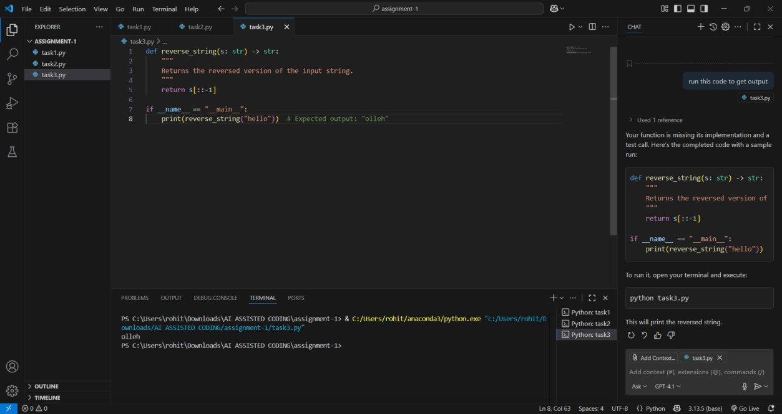

TASK DESCRIPTION 4: Generate a program that simulates a basic calculator (add, subtract, multiply, divide). Write the comment: # Simple calculator with 4 operations and let AI complete it.

PROMPT 1: generate a Python program that simulates a basic

calculator capable of performing addition, subtraction, multiplication, and division. Start with the comment # Simple calculator with 4 operations and let the AI complete the rest of the program.

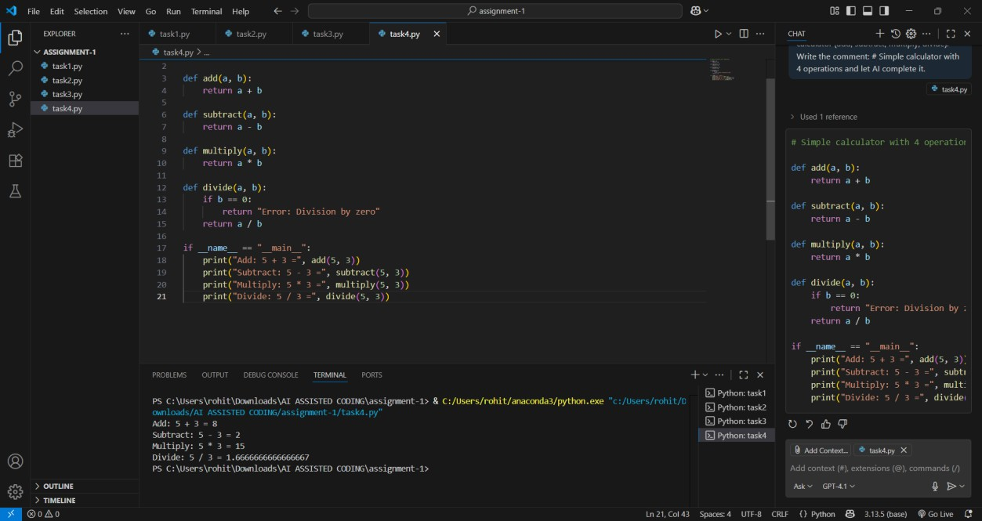

TASK DESCRIPTION 5: Use a comment to instruct AI to write a function that reads a file and returns the number of lines

PROMPT 1: generate a Python function that reads a file and returns

the number of lines in it. Begin with the comment # Function to count the number of lines in a file and let the AI complete the function.

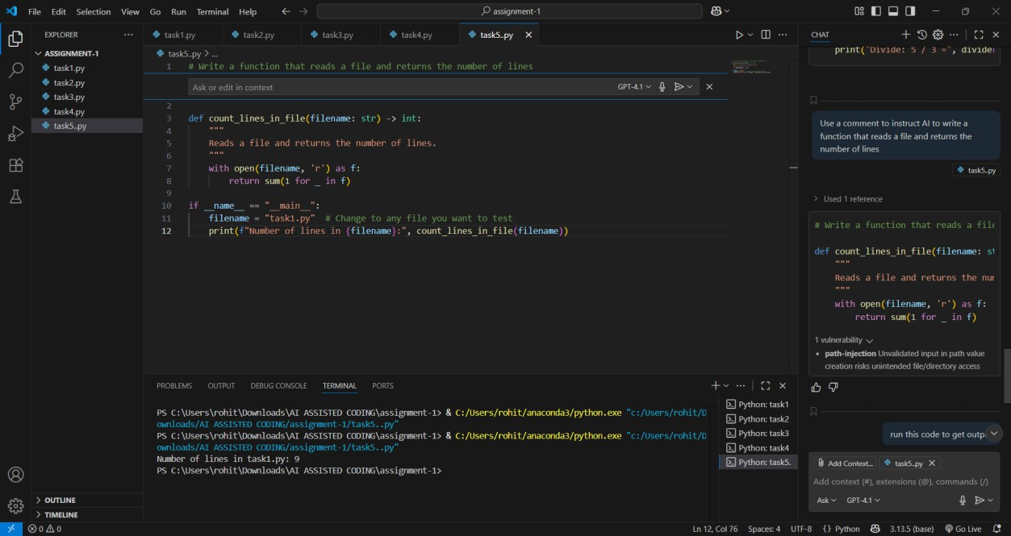

OBSERVATION: This assignment demonstrates practical use of AI- assisted coding tools to solve common programming tasks. By leveraging AI completion models like GitHub Copilot, the user was able to efficiently generate Python code for a variety of standard problems, including

palindrome checks, Fibonacci sequences, string reversal, calculator operations, and file handling.

**Key Observations**

* The assignment showcases how AI can accelerate the coding

process by accurately filling in function logic from concise prompts and comments.

* Each task starts with a clear function header or descriptive comment, allowing the AI to infer and generate the code structure and implementation for the required functionality.
* The approach encourages understanding of prompt engineering— precisely crafting comments and headers to guide AI models

towards correct and optimized solutions.

* The generated code is well-structured and solves the respective

problems: handling string manipulation, numerical computations, basic arithmetic, and file I/O.

* Overall, the assignment highlights the synergy between human intent and AI assistance in coding, increasing productivity for both simple and moderately complex programming task